


Lab 1 – Specification-Driven Embedded System Design
Embedded Processors UESTC2004 & UESTCHN2004 School of Engineering, University of Glasgow
Student Name: | Li Chenyu
Student Number: | 3073568

Lab Assessment Criteria (UESTC 2004)
Each lab will be evaluated based on the following criteria:

Demonstrating a Working Embedded System and Answering Lab Questions (70%)
- To earn full marks, you must show your system working correctly for each task in the lab manual.
- You will need to demonstrate this to the Graduate Teaching Assistant (GTA) and a staff member.

Reflection and Understanding (5%)
After completing each task, write a short reflection to explain:
- What you did – Describe the task you worked on.
- What it means – Explain its purpose or significance in the context of embedded systems.
- What’s next – Think about how this task connects to what you're learning in class or how it might apply in real-world scenarios.
💡 Be creative and think critically — avoid simply summarising what you did, as summaries won't be accepted.

Following Good Coding Practices (25%)
To score well in this area, make sure you:
- Use meaningful variable names – Avoid vague names like x, y, or personal names.
- Add comments to your code – Use block comments at the start to describe your code’s overall purpose and line comments to explain specific lines of code.
- Follow consistent indentation – Proper indentation makes your code easier to read and understand.
Here’s an example of best practices to follow and mistakes to avoid:
Good practice 🗸
#include “mbed.h”
char switch_word ; //the word we will send char recd_val; //the received value
int main() {
async_port.baud(9600); //set baud rate to 9600 recd_val = 0;
while (1)
{
switch_word=0xa0;
}
}

Avoid this ✘
#include “mbed.h”
char switch_word ;
char recd_val;
int main() {
async_port.baud(9600);
recd_val = 0;
while (1)
{
switch_word=0xa0;
}
}

Lab Objective
The purpose of this laboratory is to introduce specification-driven embedded system design. Instead of following detailed programming instructions, you will interpret a set of functional and technical requirements and implement an embedded system that satisfies them.
By the end of this laboratory, you should be able to:
- translate system specifications into embedded software behaviour
- structure embedded software using modular functions
- implement timing behaviour using software techniques
- generate and verify digital signals using an oscilloscope
- use analogue input to control system behaviour
- validate embedded system performance against requirements
This lab focuses on system design rather than step-by-step instructions.
System Overview:
In this laboratory exercise, you will design and implement a Programmable Signal Controller (PSC). Your goal is to translate a written functional specification into a working implementation, demonstrating how embedded systems evolve from requirements into real behaviour.
The PSC operates in three distinct modes, each defining how the system responds to user input and how it generates output signals:
Mode 0 – Idle:
In this resting state, the controller waits for user interaction. No output signal is generated, but the system remains responsive to mode changes.
Mode 1 – Square Wave Generator:
In this mode, the device produces a square wave digital signal. The fundamental frequency of this signal is controlled via an analogue input, allowing the user to adjust it dynamically using a potentiometer.
Mode 2 – Pattern Generator:
Here, instead of producing a simple square wave signal, the system outputs a predefined or programmable digital pattern. This illustrates how embedded systems can perform more complex timed behaviours.
To support these features, the PSC makes use of several hardware inputs and outputs:
- 1 LED indicator – used to convey system status.
- 2 push buttons – one for cycling through modes, one for resetting the system.
- 1 analogue input (potentiometer) – used to adjust parameters such as output frequency.
- 1 digital signal output – used to generate either the square wave signal or the digital pattern, depending on the mode.
For convenience, the following pin assignments are suggested:
- LED → A6
- Signal Output → D5
- Mode Button → D10
- Reset Button → D11
- Potentiometer → A0
Throughout this lab, you will interpret the system specification, design appropriate software architecture, and implement each mode’s behaviour. By the end, you will have built a flexible embedded controller driven entirely by the requirements, illustrating the core principles of specification‑driven development.

System Behaviour Overview:
The PSC system is expected to run continuously and relies solely on software‑based timing, without hardware timers, interrupts, or RTOS utilities. Short, non‑blocking delays (less than 5ms) must be used to achieve the timing requirements, and overall behaviour is expected to remain within ±10% of the stated values.
The controller begins in Mode 0 (Idle Mode). In this state, the LED remains off, and the signal output is held low. The system performs no active signal generation until the user presses the mode button, at which point it transitions to the next mode.
In Mode 1 (Square Wave Generator), the LED provides visible feedback by flashing at approximately 1 Hz, indicating that the system is actively generating a periodic waveform. The output pin produces a square wave whose period is controlled by the analogue input. The potentiometer sets the fundamental frequency smoothly across a defined range, from 100 Hz at its minimum position to 2000 Hz at its maximum, allowing the user to vary the output continuously.
In Mode 2 (Pattern Generator), the LED switches to a permanently on state, signalling that the controller is now outputting a timed digital pattern. The signal output follows a repeating sequence:
- HIGH for 10 ms
- LOW for 20 ms
- HIGH for 40 ms
- LOW for 80 ms
This four-step pattern repeats continuously for as long as the system remains in Mode 2.
Two push buttons control the system. The Mode button cycles through the three operating modes sequentially, i.e., Idle → Frequency Generator → Pattern Generator → Idle → …, with each press advancing to the next state. At any time, the Reset button immediately returns the system to Mode 0 (Idle).
This behaviour specification forms the foundation for your implementation task. Your challenge is to translate these requirements into reliable embedded software that respects the timing constraints and mode logic while operating entirely through software-controlled delays.

Task 1: Software Architecture
Before writing code, design the program structure. Your program should clearly separate:
- input reading
- mode control
- signal generation
- LED control

Draw a diagram showing the software architecture and the transition from one state to the next in your lab notebook.
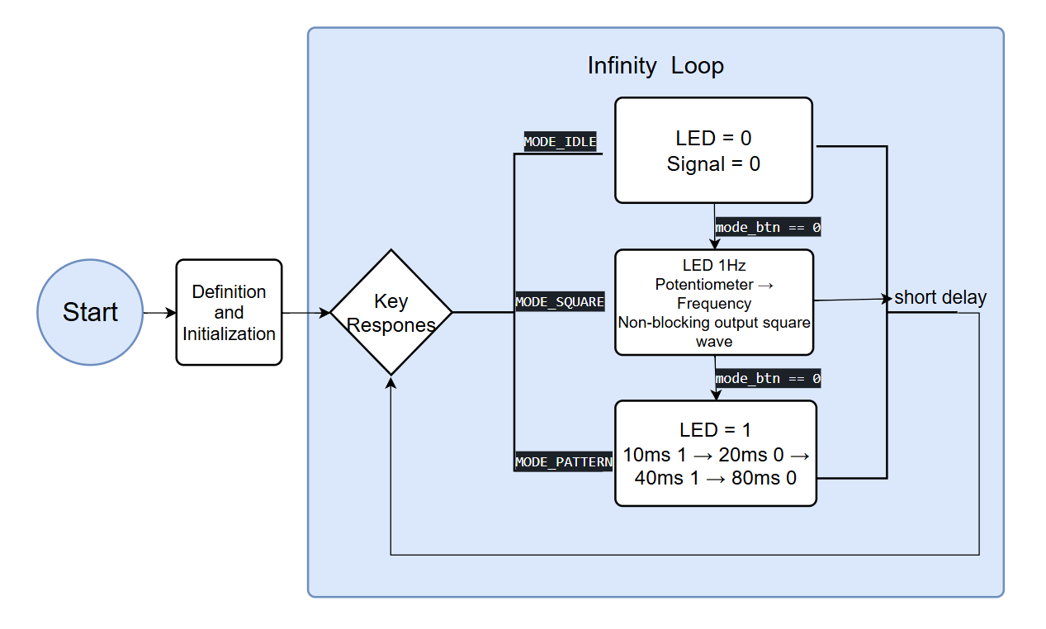I am required to design a diagram on the architecture of the embedded system in this task. My choice is to separate three tasks apart in one infinity loop, using mode button to switch between states and reset button to the idle state.
It clearly separates input reading, mode control, signal generation and LED control into independent sub-modules within one infinite loop, which aligns with the modular design principle emphasized in lectures to improve maintainability and scalability. The debounce + release-wait button logic and global state reset mechanism are optimized to prevent mechanical jitter and signal disorder, which reflects the lecture’s focus on system reliability and robustness in embedded design.
This design fully practices the specification-driven development method, translating functional requirements into a clear software architecture—directly connecting to the embedded system life cycle taught in class.

Task 2: PSC Mode Control Implementation
Implement the PSC Mode Control using LEDs only. Expected behaviour:
- Mode 0 → LED OFF
- Mode 1 → LED blinking
- Mode 2 → LED ON
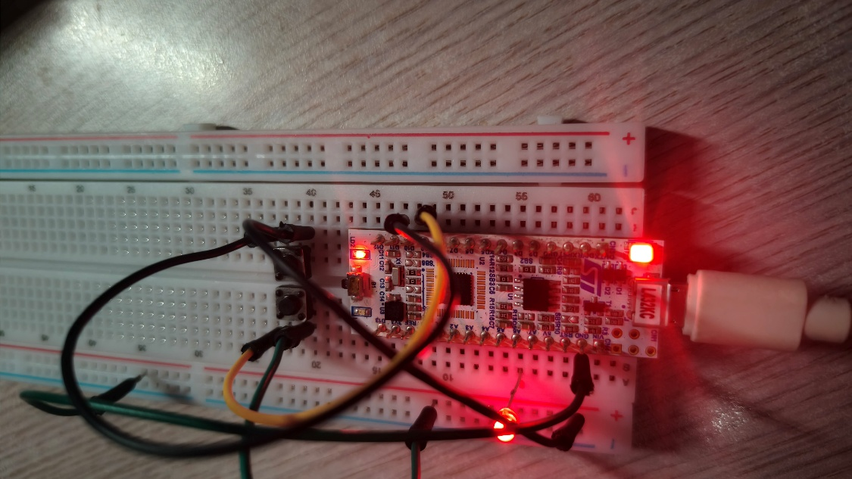
This task implements independent LED state control for the three PSC operating modes without signal output, aiming to verify the stability and correctness of mode switching logic: Mode 0 keeps the LED off, Mode 1 makes it blink at 1Hz, and Mode 2 keeps it permanently on for clear state feedback.
The core design uses us_ticker_read() to obtain system timestamps and realizes non-blocking 1Hz LED blinking via time difference comparison, ensuring the main loop remains responsive. A 4.5ms software delay handles button debounce to avoid mechanical jitter, while a release-wait mechanism guarantees one press triggers one mode switch, preventing accidental state jumps.
Experimental results confirm the system initializes to Mode 0 with the LED off; the mode button cycles through states with correct LED behavior, and the reset button instantly returns to idle mode with jitter-free switching, fully meeting task requirements.
Beyond the lab, this mode control logic mirrors real-world embedded systems—like household appliance status indicators or industrial device operation lights—where clear visual feedback and reliable state transitions are critical for user safety and device reliability. In the broader embedded field, it exemplifies the foundational principle of state machine design for resource-constrained systems, laying the groundwork for more complex applications such as IoT sensor nodes and portable medical devices, where predictable, non-blocking operation is essential for stable, long-term performance.
Task 3: PSC Square Wave Generator
Implement the frequency generator for Mode 1 and integrate it with Task 2. Requirements:
- Square wave output
- Frequency range 100 Hz – 2000 Hz
- Frequency controlled by potentiometer
Measure the signal using an oscilloscope. Record the following measurements:
Potentiometer Position | Potentiometer Value | Expected Frequency | Measured Frequency
Minimum | 0Ω | 100 | 98.6
Middle | 100Ω | 1050 | 952
Maximum | 200Ω | 2000 | 1.92k
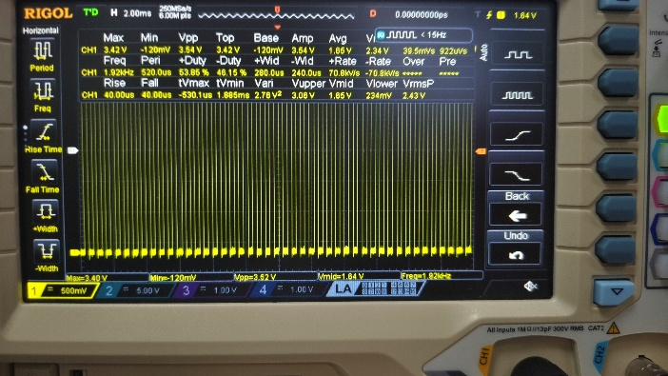
Calculate the approximate percentage error between expected and measured values.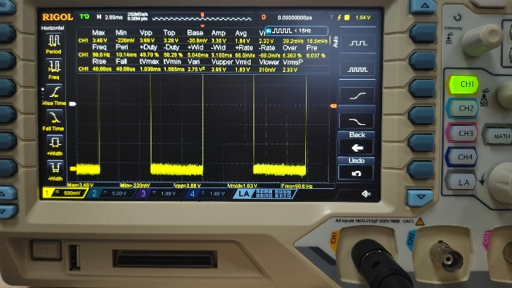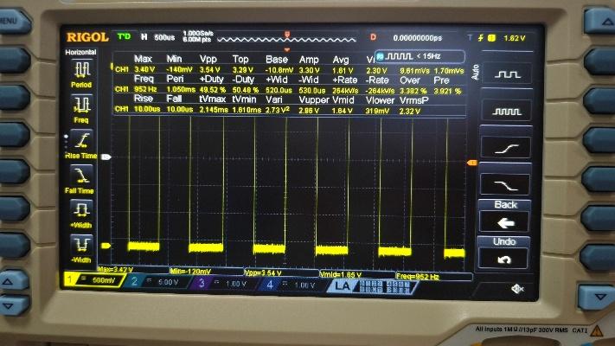
This task integrates a frequency generator into Mode 1 of the PSC system, building on the mode control logic from Task 2 to produce a square wave output with a frequency range of 100 Hz to 2000 Hz, adjustable via a potentiometer. The core design reads the analog value of the potentiometer, maps it linearly to the target frequency range, and generates a non-blocking square wave using software timestamp comparison, ensuring the main loop remains responsive while maintaining accurate timing.
Oscilloscope measurements were taken at three potentiometer positions. The minimum position has an error of 1.4%, the middle position 9.3%, and the maximum position 4.0%, with the primary sources of error being analog noise in the potentiometer reading.
In practical embedded applications, this square wave generator mirrors the function of signal conditioning modules in sensor interfaces or low-power communication devices, where adjustable frequency signals are used for data sampling or carrier wave generation. Within the embedded field, it demonstrates the critical technique of analog-to-digital conversion and software-based signal generation, laying the groundwork for more complex systems, configurable timing without dedicated hardware timers.

Task 4: PSC Pattern Generator
Implement the Mode 2 waveform and integrate it with Task 3. Required pattern:
- HIGH → 10 ms
- LOW → 20 ms
- HIGH → 40 ms
- LOW → 80 ms
Measure the cycle using an oscilloscope.
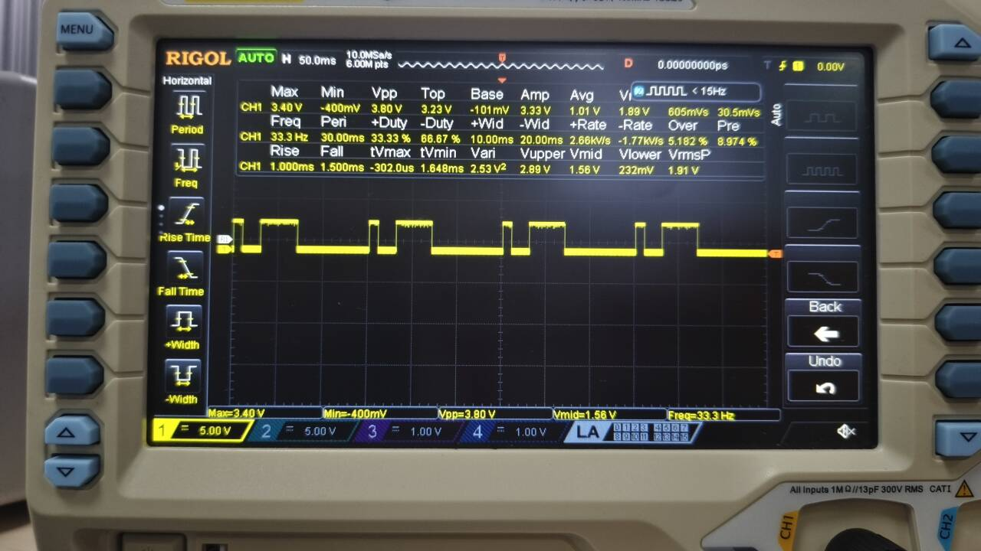
This task implements a fixed cyclic waveform in Mode 2. The core implementation uses software timestamp comparison to track each stage non-blockingly, with a step variable to manage state transitions, ensuring the main loop remains responsive while maintaining accurate timing for each segment.
Oscilloscope measurements confirm the system outputs the complete cyclic pattern as specified. The attached oscilloscope screenshot provides visual evidence of the waveform, clearly showing the four distinct time segments and their consistent repetition.
In practical embedded systems, this pattern generator mirrors the function of control signal modules in industrial automation or test equipment, where precise, repeatable timing sequences are critical for device synchronization or test procedures. Within the embedded field, it demonstrates the foundational technique of state machine design for time-critical applications, laying the groundwork for more complex systems.

Reflection
After the completion of all the tasks please reflect, in a few lines, on your understanding of the tasks and its significance. This is a chance for you to ask yourselves “What you did?”, “What it means?”, “What next?”, and/or “How else, more efficiently, can this be done?”, meaning what is the significance of the undertaken task in the context of embedded systems and what you are learning during lectures. Try to be innovative and think outside the box. Please, do not provide a summary of what you did as it will not be accepted.

This exercise transcends a simple coding task; it represents a hands-on immersion into the foundational architecture of embedded systems. By constructing the entire system within a single infinite loop, I gained a practical understanding of the super-loop architecture, a fundamental design pattern for resource-constrained microcontrollers. The core technical insight lay in mastering non-blocking software timing through timestamp comparison, which allowed the system to simulate multi-tasking without relying on hardware timers, interrupts, or an RTOS. This technique is pivotal for developing responsive systems in environments where computational overhead must be minimized.
From a systems perspective, this project reinforced the importance of state machine design as a core paradigm in embedded engineering. The seamless integration of user input (buttons), sensory feedback (potentiometer), and output logic (LEDs/waveforms) demonstrated how embedded systems interact with the physical world. It highlighted the critical role of human-computer interaction (HCI) in device usability, where precise state transitions and visual indicators form the basis of reliable user-system communication.
Looking forward, the next logical step is to bridge the gap between this basic implementation and industrial-grade systems. While the current software-based timing is sufficient for low-frequency control, future enhancements should explore hardware timer peripherals and interrupt-driven programming to achieve microsecond-level precision, significantly reducing CPU load and improving determinism. Additionally, integrating serial communication protocols (such as UART or I2C) would enable remote configuration and monitoring, transforming this standalone signal generator into a versatile test and measurement tool. Ultimately, this project serves as a stepping stone, equipping me with the fundamental logic and debugging skills necessary to tackle complex real-time embedded applications, from IoT sensor networks to industrial automation controllers.

Lab Score
Marking Criteria | Student’s Score | Comments from the GTA

Demonstration Task 1 (10%)

Demonstration Task 2 (20%)

Demonstration Task 3 (25%)

Demonstration Task 4 (20%)

Reflection (5%)

Adherence to coding good practice (20%)

